**Neighbourhoods In Mumbai**

Tanish Desai

January 13, 2021

# Introduction

## Background

Mumbai is a famous city of India where there are many places and many monuments to visit and admire the heritage of the country ,It is also a street food capital as if the street food is famous all over the world and its Maharastrian Culture and food is also famous in India ,and there are many more places to visit in each area of Mumbai ,its is having vast population and number of places to visit there

## Problem

Data that might contribute to Peoples to know about where to Buy a house in which are as if we shortlist some common venues nearby an area so that its helpful to the peoples living nearby and ,Families which are moving to Mumbai to start a new life as well as students Coming to study in Mumbai

# Data acquisition and cleaning

## Data sources

The Source of Data is Wikipeida Neighbourhoods in Mumbai from where we found list of places in Mumbai , and futher we would work on it wo get the output

## Data cleaning

We have used data available from the Wikipedia itself (“Neighbourhoods_in_Mumbai”)and cleaned the data

# Exploratory Data Analysis

EDA is not used we have just made a map for Neighbours

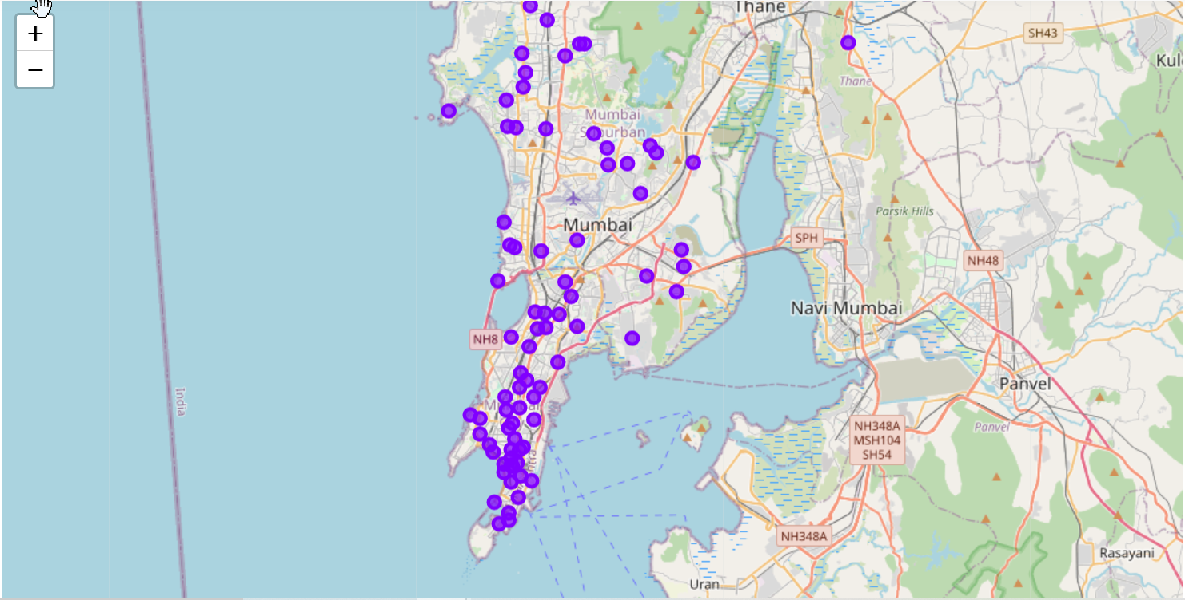

# Modeling

## K-means Clustering

### Applying standard algorithms and their problems

K means clustering is used to get the most usefull venues nearby,

If a Citizen tend to shift to any particular area in Mumbai he/she can get idea about local ameneties nearby and just rethink of shifting the to place

### Solution

After plotting the graph we have finalized the top most 10 venues nearby a particular areas in Mumbai ,that would help all the peoples living nearby to find the accurate place to take a house and start making use of amenities nearby

New Builders can also have an idea about the most common places nearby the area and plan accordingly to work on place development and ameneties

.

# Conclusions

In this study, I analysed the nearby locations of places in Mumbai and I found out top 10 most visited venues nearby

So that it could help the peoples living nearby as well as the peoples want to start new business but not sure in which area which these study they can be more accurate on shortlisting there idea of business on based of most famous places and visiting places near by the areas in Mumbai

